**Enumerated Datatypes and Typedefs assignments**

Mandatory

1. WAP to define an enum to store designations in an organization. List of possible values are

{E2F=1, E2, E3, E4, E5}

Prompt and read a designation from the user. Then display his designation string such as

Designation Designation String

E2F Software Fresher

E2 Software Engineer

E3 Senior Software Engineer

E4 Team Lead

E5 Senior Team Lead

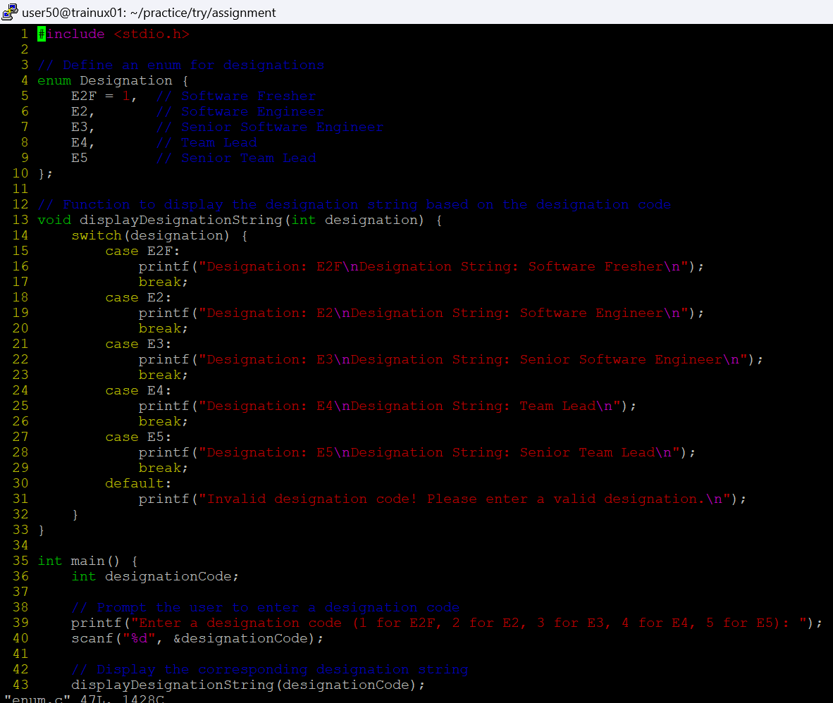

2. Define a typedef structure to keep the configuration of putty server. Identify and place all the required members. Create a structure variable and initialize it with user defined values and finally display the contents.



